

TDI Capstone Project Documentation
Name: Felicitas Ezechikeluba
Track: Data Analytics
Cohort: Sapphire
Tool: Power BI

TITLE
Hospital Records Analysis: Healthcare Utilization and Cost Insights
Subtitle: Driving Efficiency, Financial Performance, and Policy Support
DASHBOARD:
Hospital Performance Report: Driving Efficiency, Cost Management, and Policy Support”
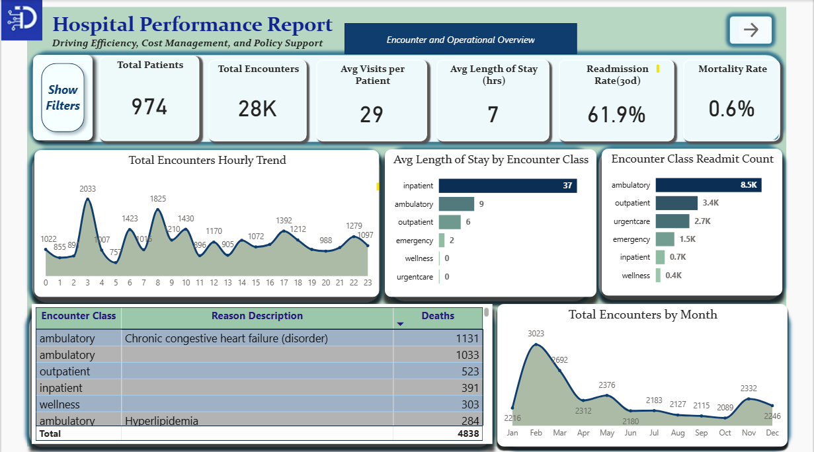
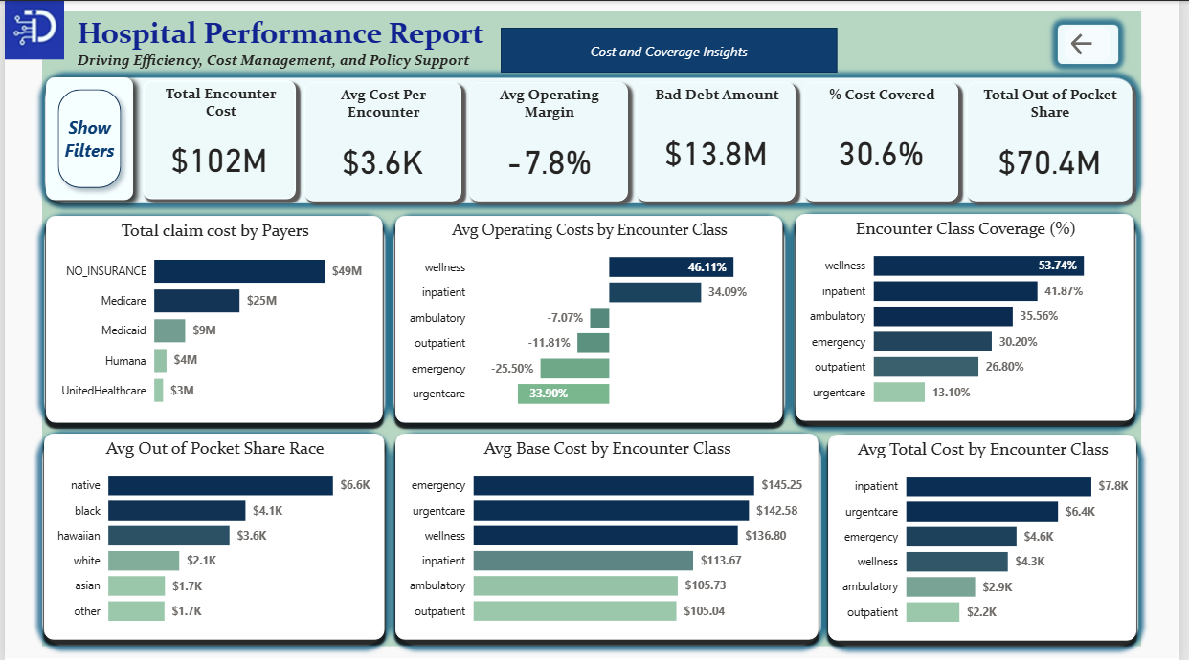

Disclaimer:
Some figures in this report use proxy metrics (e.g., Base Encounter Cost for operating cost, Payer Coverage for revenue). These estimates offer directional insight but don’t reflect full financial accuracy. Results are indicative, not definitive, and unsuitable for audited or regulatory reporting.
OVERVIEW
This project explores synthetic patient data (~1,000 records) from Massachusetts General Hospital spanning 2011–2022. The dataset captures demographics, insurance coverage, medical encounters, and procedures.
It explores how patient and insurance factors influence healthcare use and hospital performance.
While the data is synthetic, the insights mirror real-world challenges in balancing quality care with financial sustainability. Early findings point to areas where efficiency, patient equity, and financial performance intersect—key levers for both healthcare providers and policymakers.
INTRODUCTION
Healthcare utilization refers to the extent and pattern of how individuals and populations access and use health services. This includes preventive, diagnostic, and treatment services, as well as the information patients receive about their health status (National Academies of Sciences, Engineering, and Medicine, 2018). Utilization is typically measured by what types of care are used, how often, and when. It is influenced by health needs, the availability and accessibility of services, economic status, health beliefs, and communication between providers and patients.
Over the past decades, the healthcare delivery system has undergone significant change. Advances in drugs, devices, procedures, and imaging technologies have shifted care toward ambulatory and outpatient settings, while also reducing the average length of hospitalizations (NCHS, 2016). At the same time, newer and improved healthcare services have not been equally available across populations. For example, disparities exist in access to outpatient surgery across racial and socioeconomic groups (Salasky et al., 2014; MACPAC, 2016).
Despite progress, hospitals continue to face critical challenges. Major industry-wide issues include workforce shortages leading to burnout and increased labor costs, rising expenses for both providers and patients, and the difficulty of integrating new technologies securely. Hospitals must also address patient safety and experience, the growing care burden of an aging population with chronic diseases, inequities in access to care, complex regulatory requirements, and the need for stronger patient engagement.
Within this context, healthcare utilization provides a powerful lens to evaluate hospital performance. Consumption of services, patterns of use, and the appropriateness of care all reflect how efficiently a hospital meets the needs of its population. Utilization is driven not only by patient health needs and economic resources, but also by availability of facilities, patient characteristics, and system-level factors such as provider trust and organizational policies (National Academies of Sciences, Engineering, and Medicine, 2018).
Purpose of the Study
This report investigates hospital records to understand healthcare utilization and financial insights, with the goal of improving operational efficiency, tracking financial performance, reducing service costs, and supporting government health insurance policy.
Key Stakeholders
The main stakeholders expected to benefit from this study are:
- Policy makers (government and state), who rely on utilization and cost data to design and evaluate insurance programs.
- Hospital directors, who need operational and financial insights to manage resources effectively.
- Investors, who require a clear picture of performance, cost efficiency, and long-term sustainability.

PROBLEM STATEMENT
How can hospitals improve efficiency and expand access to healthcare to serve patients better, while maintaining financial sustainability and supporting policy goals?

CASE BACKGROUND
The healthcare industry is under mounting pressure to deliver high-quality care while controlling costs and meeting the needs of diverse populations. Hospitals, as the core of this system, face an evolving set of challenges shaped by financial pressures, operational inefficiencies, and demographic shifts. These issues are not isolated; they directly affect patients, providers, policymakers, and investors alike, making efficient healthcare utilization and financial insight more critical than ever.
Cost and Financial Pressures
- Rising Costs: The cost of healthcare services, medications, and new technologies continue to climb, creating financial strain for both providers and patients. Hospitals must absorb these costs while remaining financially viable.
- Tight Budgets: Many healthcare organizations operate within strict budget constraints, limiting their ability to invest in infrastructure, staff, and innovation.
- Operational Inefficiencies: Hospitals often struggle with burdensome administrative processes and inefficient workflows, which divert resources away from direct patient care.
Access and Utilization Challenges
- Inequities in Access: Disparities in access to quality healthcare persist, particularly in rural areas and underserved communities, limiting utilization of essential services.
- Aging Population: The growing number of elderly patients with chronic conditions increases demand for hospital encounters, lengthens care needs, and intensifies cost pressures.
Why This Case Is Relevant
This case study is relevant because it addresses the intersection of healthcare utilization and financial performance—two areas critical for improving efficiency, reducing costs, and expanding equitable access. By analyzing hospital encounter data, the study aims to provide insights that can:
- Help policymakers design stronger insurance frameworks and resource allocation strategies.
- Enable hospital directors to streamline operations, improve patient outcomes, and manage costs more effectively.
- Provide investors with a clearer picture of hospital performance, sustainability, and return on investment.
In short, the pressures of rising costs, limited resources, and shifting patient demographics make this analysis timely and important for stakeholders seeking to improve healthcare delivery while ensuring financial sustainability.
GOALS
The goal of this case study is to leverage hospital encounter data to generate insights that improve healthcare utilization, financial performance, and operational efficiency. Specifically, the study aims to:
- Enhance Efficiency: Identify patterns and bottlenecks in hospital operations to streamline workflows and reduce inefficiencies.
- Improve Access and Equity: Highlight disparities in utilization across patients, payers, and encounter types to inform more inclusive service delivery.
- Strengthen Financial Sustainability: Track costs, claim coverage, and payer distributions to ensure hospitals can balance service quality with fiscal responsibility.
- Support Policy and Decision-Making: Provide evidence-based insights that assist government and hospital leaders in shaping health insurance policies and resource allocation.
Success will be defined by the ability to transform raw hospital records into actionable insights that help patients receive better care, directors manage resources effectively, and policymakers design stronger healthcare frameworks.
OBJECTIVES
The study seeks to:
- Analyze encounter data to identify trends in utilization, costs, and claim coverage.
- Measure key hospital metrics such as mortality rate, readmission rate, and average length of stay.
- Compare base costs and total claim costs across encounter classes and payers.
- Detect inefficiencies, including encounters with zero coverage or unusually long durations.
- Provide dashboards that summarize KPIs for policymakers, hospital directors, and investors.

BUSINESS QUESTIONS
Analysis questions were structured across key reporting segments including Encounters, Operations, Cost, Insurance, and KPIs, with tooltips and drill-throughs for deeper insights.
KEY BUSINESS QUESTIONS
- What times of day and which encounter classes see the highest volume?
- Which encounter classes have the longest stays
- Which encounter class has the most readmissions?
- Which encounter reasons account for most deaths?
- How do encounters trend by year, month?
- Which encounter classes and procedures drive the highest claim costs?
- Which encounter classes with highest base cost
- Which encounter class generates most profits?
- What is the % of encounters Cost covered by Insurance
- Are out-of-pocket expenses higher for certain demographics?
- Which insurers cover the largest share of costs?

Dashboard 1: Encounter & Operational Overview
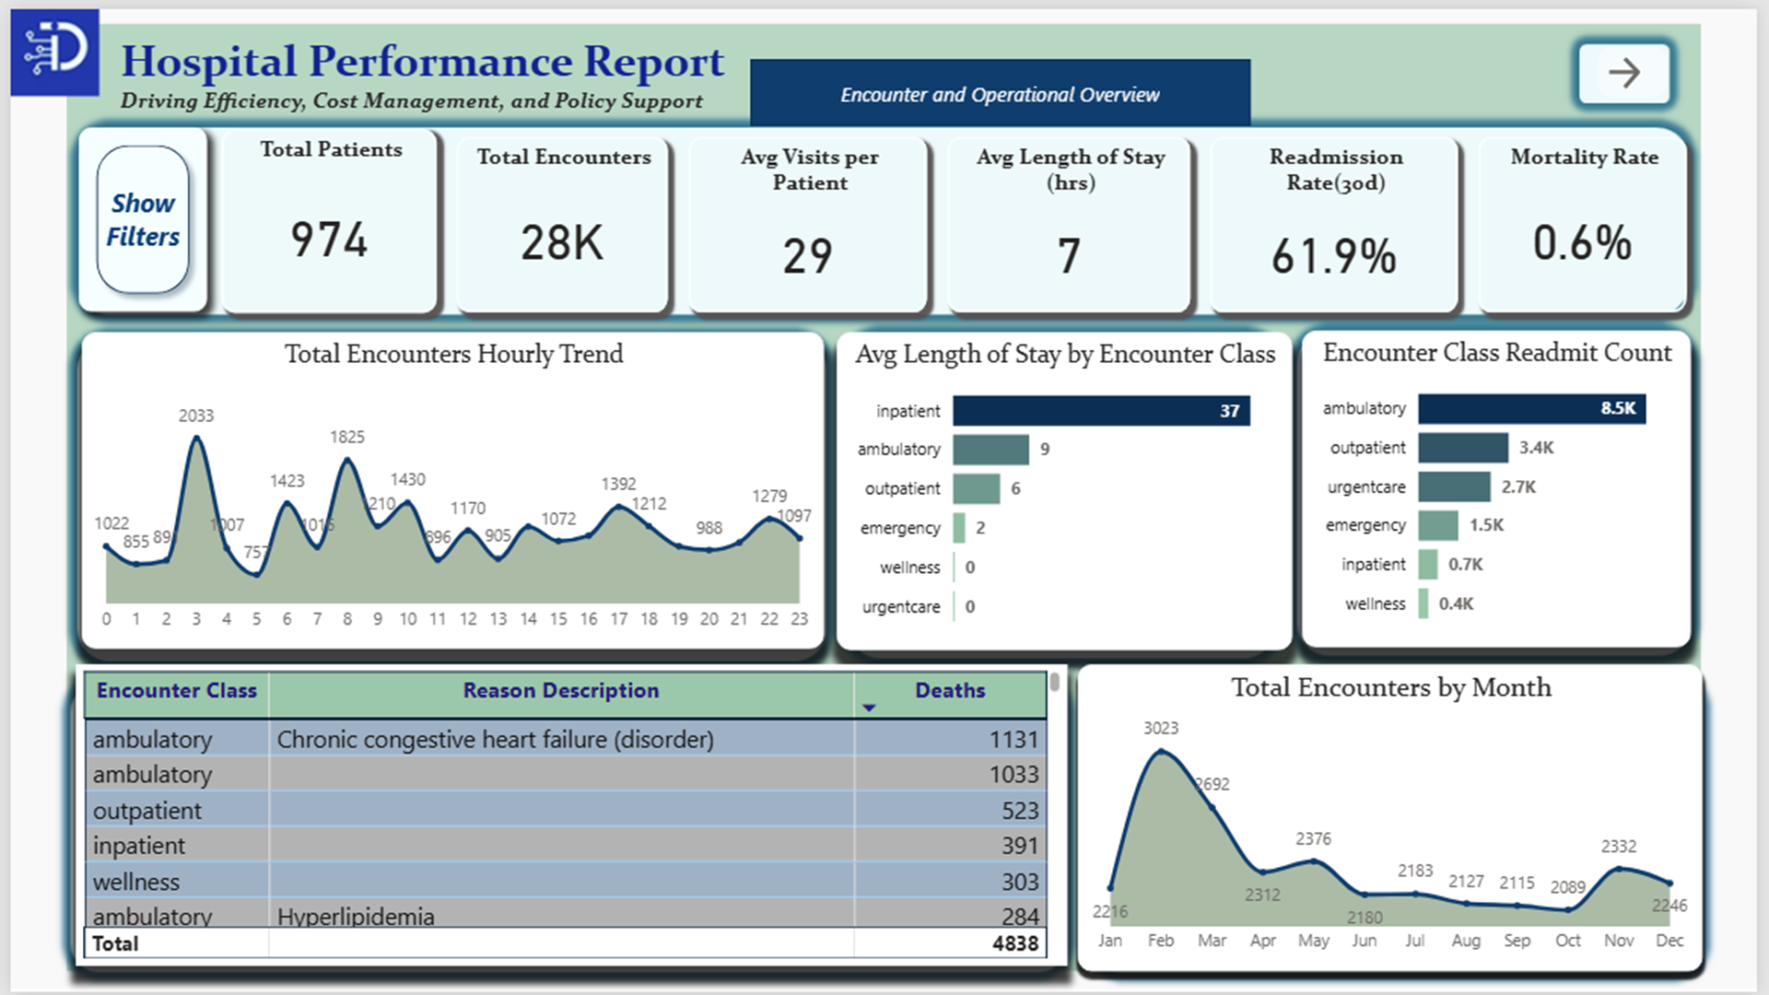
KPI’S
• Total Patients : Unique individuals served.
• Total encounters : All recorded visits or admissions
• Average visits per patient : Encounters per unique patient.
• Average length of stay(hrs.): Mean time patients spend in care.
• Readmission rate : % of patients returning within 30 days
• Mortality rate : % of patients who died during encounters.
Other Analysis Questions
- What times of day and which encounter classes see the highest volume?
- Which encounter classes have the longest stays
- Which encounter class has the most readmissions?
- Which encounter reasons account for most deaths?
- How do encounters trend by year, month?
Drill-Through
- Encounter class distribution (%) by year
- Which departments or services have the highest patient volume and readmit count?
Tooltip
- How do Encounters vary by class

Dashboard 2: Cost & Insurance Insights
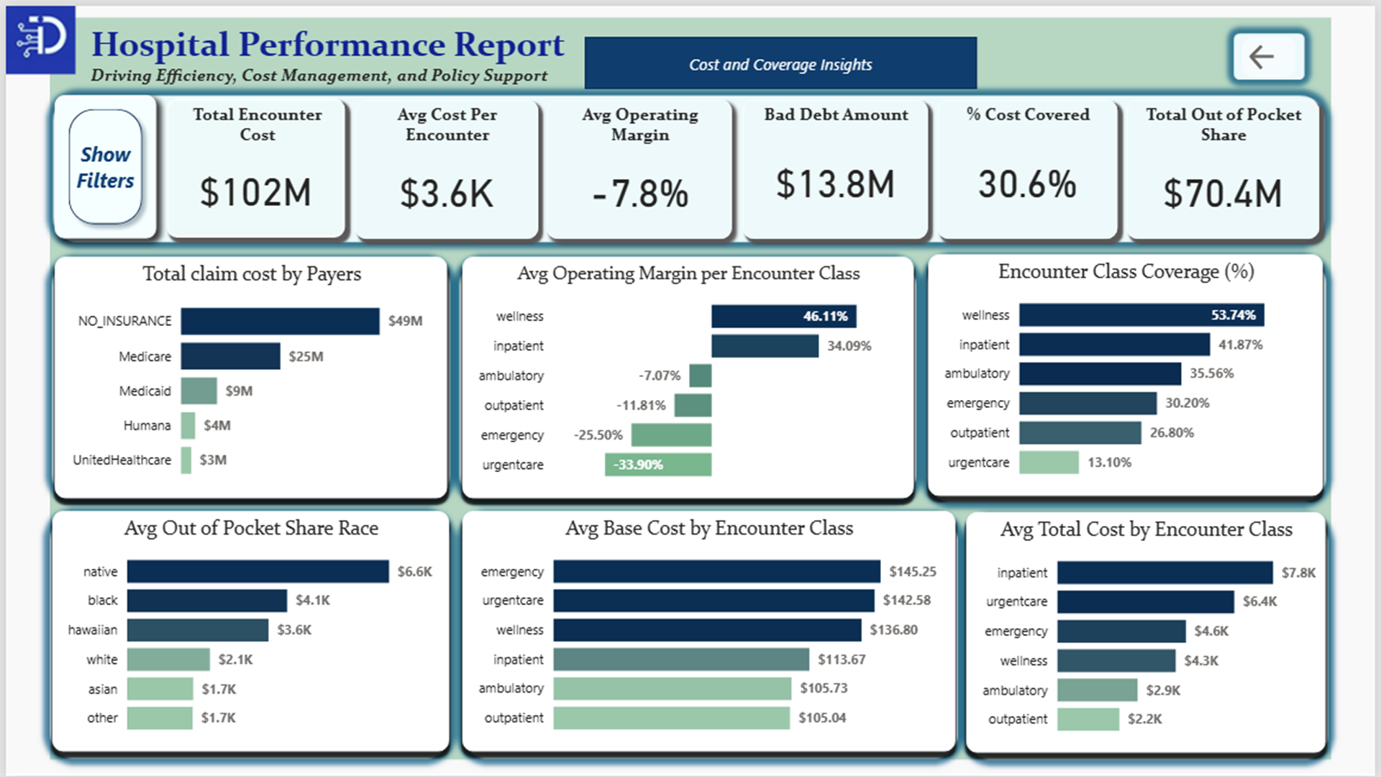
KPI'S
• Total Encounter Cost : Total hospital spending on all patient encounters.
• Average cost per encounter : Mean cost per patient visit.
• Average operating margin : % of profit retained after operating costs.
• Bad Debt Amount : Unpaid costs from insurers.
• % cost covered : Portion of costs paid by insurers.
• Total Out-of-Pocket Share : Sum of costs patients personally paid.
Other Analysis Questions
- Which encounter classes and procedures drive the highest claim costs?
- Which encounter classes with highest base cost
- Which encounter class generates most profits?
- What is the % of encounters Cost covered by Insurance
- Are out-of-pocket expenses higher for certain demographics?
- Which insurers cover the largest share of costs?
Drill-Through
- Which encounter class has most unpaid costs from insurers?
- Coverage distribution (insured vs uninsured)
- Which encounter class generates the most revenue(proxy)?
- What are the most common procedures, and how do their costs compare?
Tooltip
- Which encounter classes drive the highest total costs?
- Encounter classes with highest base cost
- Insurance coverage counts by race
METHODOLOGY
This project was approached using a structured data analytics workflow, with Power BI as the main tool. The process began with Exploratory Data Analysis (EDA) to understand the dataset’s structure, which consists of Data Cleaning & Preprocessing in Power Query Editor to address nulls, duplicates, grouping inconsistencies, and billing integrity issues. After ensuring data quality, a star schema model was built, supported by a date table for time-series analysis.
The dataset itself, as detailed in the Data Description section, was sourced from the Maven Analytics Playground and provided in a bundled zip file with SQL scripts, CSVs, and supporting documentation.
EXPLORATORY DATA ANALYSIS (EDA)
EDA helps better understand the characteristics of your data, reveal hidden patterns, spot anomalies, and understand relationships in data. It ensures you know your dataset’s structure and helps in deciding the correct models or methodologies before modeling or deeper analysis.
Data Cleaning & Preprocessing
Before performing EDA, it’s important to clean and preprocess your data. During EDA, you can identify missing values, incorrect data types, and outliers, ensuring data quality before further analysis.
In Power BI, start by opening Power BI Desktop → Get Data → select your source (Excel, CSV, etc.) → load relevant tables/sheets. Preview before importing.
Use Power Query Editor to:
- Turn on Column quality, Column distribution, and Column profile to examine data.
- Apply transformations: remove duplicates, fix data types, replace errors, and format columns.
DATA CLEANING
Checked for nulls, duplicates, and validated data types.
Built relationships across tables for a star schema (Encounters as Fact).
Created a Date Table for time-series intelligence (trends, seasonality).

Data Quality
During data review, a few issues came up that could affect analysis:
1. Null Values
- Marital Status → One patient over 50 had no marital status recorded. Likely a data entry gap.
  - Options: delete the row or fill it with the mode.
  - Decision: Filled with the mode (“Married”), since it was the most common value.
- Total_Claim_Cost = 0 → Several encounters showed zero claim cost, even though services were logged. This could be:
  - Death certification → logged for records, not billed.
  - Hospice admission → sometimes bundled, prepaid, or written off.
  - ER or ICU admissions → may fall under global payments or uninsured/self-pay cases.
  - Wellness / reevaluations → preventive encounters not always billable.
→ These patterns suggest some zeros might reflect billing realities, while others could be data gaps.
- Payer Coverage Nulls/Zeroes → A few cases had claim costs but no coverage. Could point to hospice, admin tasks, self-pay, missing payer info, or denied claims.
2. Inconsistency in Data Grouping
Some encounter descriptions were assigned to the wrong categories:
- “Periodic reevaluation and management of healthy individual” → grouped under Inpatient.
- “Death certification” → grouped under Wellness.
Why this might happen: Hospitals rely on ICD, CPT, or SNOMED codes. These coding systems sometimes force odd groupings, more about taxonomy than clinical sense.
Why it matters:
- Leads to strange insights (like death = wellness).
- Dashboards can misreport trends if not corrected.
- Best approach: reclassify or flag these outliers during analysis.
3. Data & Billing Integrity
Some encounter types (like hospice, overdoses, or admin processes) may not generate claims, even if base costs exist. It’s unclear whether this is by design (billing rules) or missing data, so these rows need careful interpretation.
DATA DESCRIPTION
• Case Materials
A zip folder containing hospital and patient records, structured as follows:
- SQL Files:
  - create_hospital_db.sql → script to set up the database.
  - hospital_analytics_questions.sql → queries for analysis.
- Text File:
  - citation.txt → reference and citation details.
- CSV Files (for import):
  - data_dictionary.csv
  - encounters.csv
  - organizations.csv
  - patients.csv
  - payers.csv
  - procedures.csv
•Data Sources
The dataset was obtained from the Maven Analytics Playground, an open-source platform for learning and practicing analytics.
Data Collection
The data was accessed directly from Maven’s publicly available repository and downloaded as part of a bundled zip file containing SQL scripts, a citation note, and CSV files for hospital and patient records.

ANALYSIS
Dashboard 1: Encounter & Operational
KPI'S
- Total Patients
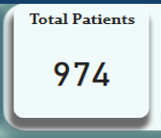
Approach
- I created a measure Total Patients with the Id column in the Patients table
DAX Formula: Total Patients = DISTINCTCOUNT('Patients'[id])
- Then visualized using a KPI Card

- Total encounters
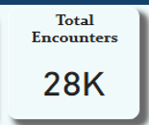
Approach
- I visualized using a KPI Card with Encounter code column (count)

- Average visits per patient
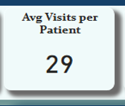
Approach
- I created a measure Avg Visits per Patient with the Patient column in the Encounters table
DAX Formula: Avg Visits per Patient = DIVIDE( COUNTROWS('Encounters'), DISTINCTCOUNT('Encounters'[Patient]), 0 )
- Then visualized using a KPI Card

- Average length of stay
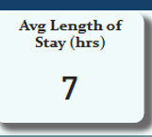
Approach
- I created a measure LOS_Hours with the Start and Stop columns in the Encounters table
DAX Formula: LOS_Hours = DATEDIFF ( 'Encounters'[Start], 'Encounters'[Stop], HOUR)
- Then visualized using a KPI Card (aggregated measure to average)

- Readmission rate(30 days) %

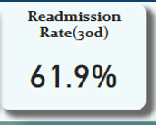
Approach
I created 2 calculated columns and 1 measure to achieve this
Calculated Columns:
- DAX Formula: Next_Encounter_Date = CALCULATE( MIN('Encounters'[Start]), FILTER( 'Encounters', 'Encounters'[Patient] = EARLIER('Encounters'[Patient]) && 'Encounters'[Start] > EARLIER('Encounters'[Start]) ) )
- DAX Formula: Readmit30Flag = IF( NOT( ISBLANK('Encounters'[Next_Encounter_Date]) ) && DATEDIFF('Encounters'[Start], 'Encounters'[Next_Encounter_Date], DAY)
<= 30, 1, 0 )
Measure:
- DAX Formula: Readmission Rate (30d) = DIVIDE( SUM('Encounters'[Readmit30Flag]), COUNTROWS('Encounters'), 0 )
- Then visualized using a KPI Card

- Mortality rate
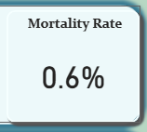
Approach
- I created a measure Mortality Rate with the deathdate column in the Patients table and id column in Encounters table
DAX Formula: Mortality Rate = DIVIDE( COUNT('Patients'[deathdate]), COUNT('Encounters'[id]), 0 )
Then visualized using a KPI Card

Other Analysis Questions
1. What times of day and which encounter classes see the highest volume?
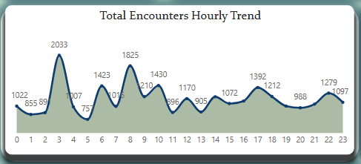
Approach
- I created a new calculated column StartHour column from the Start Date column
DAX Formula: StartHour = HOUR ( 'Encounters'[Start] )
- Then visualized using a line chart
X-axis = StartHour
Y-axis = Id column(Count)

Findings
- The data shows that the 3rd hr. mark has the highest volume of 2,033 encounters, the 8th and 10th hr. follow closely with 1,825 and 1,423 encounters.
- Encounter classes filtered at those hours showed ambulatory, outpatient, urgentcare and emergency to be the top.

Insights
Ambulatory and urgent care cases rose usually at 3 a.m. and early hours in the morning, this surge could indicate high overnight demand for non-scheduled, semi-urgent cases.

2. Which encounter classes have the longest stays
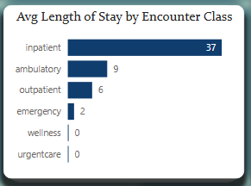
Approach
- I visualized using a bar chart
X-axis = LOS_Hours measure(aggregated by Average)
Y-axis = Encounter Class
Findings
- The data shows that Inpatient, ambulatory and outpatient classes, had the average longest length of stays, with 37, 9, 6 hours
Insights
- Inpatient, ambulatory and outpatient encounters had the longest average length of stay, this highlights a higher resource use, treatment complexity and potential cost concentration

3. Which encounter class has the most readmissions?
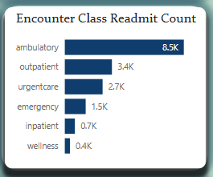
Approach
- I created a measure Readmit Count with the Readmit30Flag Column in Encounters table
DAX Formula: Readmit Count = SUM(('Encounters'[Readmit30Flag]))
- Then visualized using a bar chart
X-axis = Readmit Count
Y-axis = Encounter Class

Findings
- The data revealed that ambulatory class had the most readmission count of 8,500, followed closely by outpatient, urgentcare, and emergency at 3,400, 2,700 and 1,500 total cases respectively
Insights
The high readmission volume in ambulatory care may point to gaps in follow-up or post-discharge management, signaling an area for quality improvement or cost reduction.

4. Which encounter reasons account for most deaths?
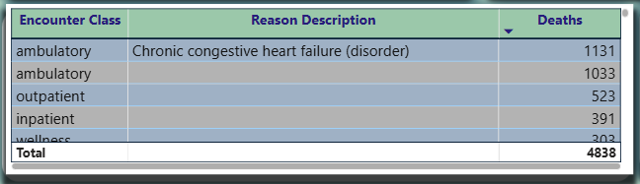
Approach
- I created a measure Deaths by encounter with the Death Date column in patients table
DAX Formula: Deaths by Encounter = CALCULATE(COUNTROWS('Encounters'), FILTER('Encounters', NOT(ISBLANK( RELATED('Patients'[deathdate]) ))) ) )
- Then visualized using a table
Columns = Encounter Class, Reason Description, Deaths by encounter

Findings
- Chronic congestive heart failure and cases with unclear reasons in ambulatory class accounted for most death, followed by outpatients also with no records .
- A drill-down investigation of the unclear reasons showed a description pattern of cardiac and mental health issues, end of life care and domestic abuse and fall risk cases
Insights
High mortality in ambulatory cases suggests possible misclassification of critical or palliative patients and gaps in preventive or follow-up care.

5. How do encounters trend by year, month?
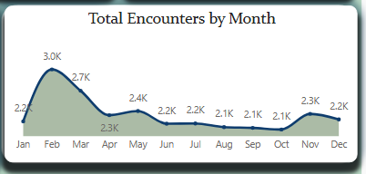
Approach
- I created a Date table from the Start Date and Stop Date from encounters table as Min and Max date
DAX Formula Date =
VAR MinDate = DATE ( YEAR ( MIN(Encounters[START]) ), 1, 2 )
VAR MaxDate = DATE ( YEAR ( MAX(Encounters[STOP]) ), 2, 5 )
RETURN
ADDCOLUMNS (
CALENDAR ( MinDate, MaxDate ),
"Year", YEAR ( [Date] ),
"Quarter Number", QUARTER ( [Date] ),
"Quarter", "Q" & QUARTER ( [Date] ),
"MonthNumber", MONTH ( [Date] ),
"Month", FORMAT ( [Date], "MMMM" ),
"MonthName", FORMAT ( [Date], "MMM" ),
"YearMonth", FORMAT ( [Date], "yyyy-MM" ),
"Day Number", DAY ( [Date] ),
"DayOfWeek", WEEKDAY ( [Date], 2 ), -- 1=Sunday, 2=Monday
"DayName", FORMAT ( [Date], "dddd" ) )
Then visualized using a line chart
X-axis = MonthName
Y-axis = Id column(Count)

Findings
The data showed that the:
- Peak Month for patient encounters is in February and March, the trend remains relatively steady for the rest of the year.
- Peak Year for patient encounters was in 2014 and 2021 in those months
Insights
Seasonal spikes in early-year encounters (Feb–Mar) may reflect post-holiday health checkups, flu-related visits, or scheduled follow-ups, while the 2014 and 2021 peaks may tie to policy or pandemic-related factors.
Drill-Through
1. Encounter class distribution (%) by year
Approach
- I created a new calculated column StartYear column from the Start Date column
DAX Formula: StartYear = YEAR ( 'Encounters'[Start] )
- Then visualized using a stacked bar chart
X-axis = Id column(Count)
Y-axis = StartYear
Legend = Encounter class
2. Which departments or services have the highest patient volume and readmit count?
Approach
- I visualized using a Table
Columns = Encounter Class, Encounters, Readmit Count, Reason Description, Description
Tooltip
1. How do Encounters vary by class?
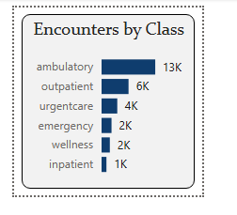
Approach
- I visualized using a bar chart
X-axis = Id column(Count)
Y-axis = Encounters Class
Dashboard 2: Cost & Insurance Insights
KPI'S
• Total Encounter Cost
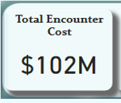
Approach
- I created a conditional column Total Cost in Power Query to combine patient costs — assigning Base Encounter Cost for uninsured patients and Total Claim Cost for insured ones.
Power Query (M): Total Cost = if [Base_Encounter_Cost] = 0 and [Total_Claim_Cost] = 0 then [Base_Encounter_Cost] else [Total_Claim_Cost]
The result was visualized using a KPI Card, aggregating the column by Sum

- Average cost per encounter
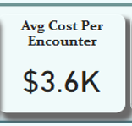
Approach
- I created a measure Avg Cost per Encounter from the Total Cost column in Encounters table
DAX Formula: Avg Cost per Encounter = AVERAGE('Encounters'[TOTAL_COST])
Then visualized using a KPI Card(Aggregated measure by Average)

• Average operating margin
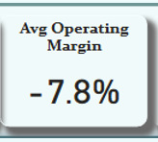
Approach
- I created 2 measures Revenue & Avg Operating Margin
DAX Formula: Revenue (Proxy) = IF( ('Encounters'[Payer_Coverage] = 0 || ISBLANK('Encounters'[Payer_Coverage])) &&
('Encounters'[Total_Claim_Cost] = 0 || ISBLANK('Encounters'[Total_Claim_Cost])),
'Encounters'[Base_Encounter_Cost],
[PAYER_COVERAGE] )
DAX Formula: Avg Operating Margin = AVERAGEX( 'Encounters',
DIVIDE( 'Encounters'[Revenue (Proxy)] - 'Encounters'[BASE_ENCOUNTER_COST],
'Encounters'[Revenue (Proxy)], 0 ) )
- Then visualized using a KPI Card
Fields = Avg Operating Margin

• Bad Debt Amount
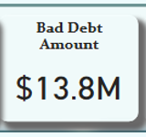
Approach
- I created a Measure BadDebtAmount
DAX Formula: BadDebtAmount = SUMX( FILTER( 'Encounters', RELATED('Hmo Payers'[NAME]) <> "NO_INSURANCE" && 'Encounters'[Payer_Coverage] = 0 ),
'Encounters'[Total_Claim_Cost)
- Then visualized using a KPI Card
Fields = BadDebtAmount
• % cost covered
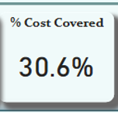
Approach
- I created a measure %Cost Covered
DAX Formula: % of cost Covered = DIVIDE(SUM('Encounters'[Payer_coverage]), SUM('Encounters'[Total_Claim_Cost]), 0)
- Then visualized using a KPI Card
- Fields = %Cost Covered
• Total Out-of-Pocket Share
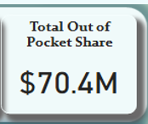
Approach
- I created a new calculated column OOP_Amount, then a measure Total_OOP
DAX Formula: OOP_Amount = [TOTAL_COST] - [PAYER_COVERAGE
DAX Formula: Total_OOP = SUM('Encounters'[OOP_Amount])
- Then visualized using a KPI Card
Fields = Total_OOP
Other Analysis Questions
1. Which insurers cover the largest share of costs?
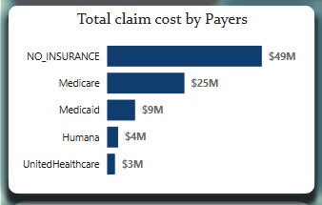
Approach
- I visualized using a bar chart
X-axis = TOTAL_CLAIM_COST(sum aggregated)
Y-axis = NAME
Findings
- The data shows that the No Insurance category takes the top of large share of costs at 49M USD, followed by medicare, Medicaid at 25M & 9M USD respectively
Insights
The largest share of costs is covered by patients with no insurance; this shows a big coverage gaps and indicates systemic underinsurance and weak private payer support. Medicare’s strong share suggests it’s the most reliable payer
2. Which encounter class generates most profits?
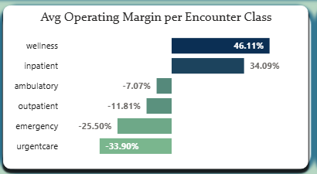
Approach
- I visualized using a bar chart
X-axis = Avg Operating Margin
Y-axis = ENCOUNTER CLASS
Findings
- The data revealed that wellness and inpatient classes generates good profit at 46.11% and 34.09%,
- Urgent care class had a low profit return at a negative 33.90%, followed closely by emergency cases at -25.50%
Insights
Results suggests that resource-intensive acute care services strain margins, while preventive and planned care remain financially sustainable.
3. What is the % of encounters Cost covered by Insurance
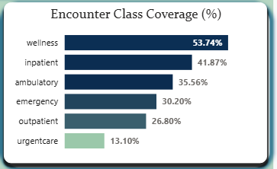
Approach
- I visualized using a bar chart
X-axis = % of cost Covered
Y-axis ENCOUNTER CLASS
Findings
- Wellness, inpatient, ambulatory, emerge top 3 of classes with a high-cost insurance coverage at 53.74%,41.87%, 35.56% respectively, with urgentcare at the bottom with 13.10%
Insights
Coverage is focused on low-risk classes, while critical ones get minimal support — showing misaligned payer priorities and a need to shift coverage toward higher-risk, higher-readmission groups.
4. Are out-of-pocket expenses higher for certain demographics?
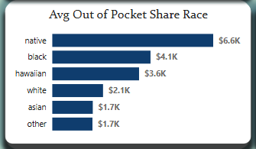
Approach
- I created a measure Avg OOP by Group
DAX Formula: Avg OOP by Group = AVERAGEX( VALUES('Patients'[Race]), CALCULATE( AVERAGE('Encounters'[OOP_Amount]) ) )
- Then visualized using a line chart
X-axis = Avg OOP by Group
Y-axis = RACE
Findings
- The data showed that Natives($6.6k), Blacks($4.1k) and Hawaiians($3.6k), pay more out of their pocket than other races
Insights
Natives, blacks and Hawaiians, Pay more out of their pocket than other races
5. Which encounter classes with highest base cost
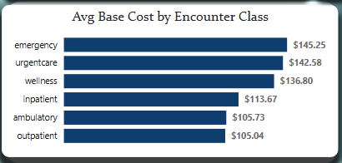
Approach
- I visualized using a bar chart
X-axis = BASE_ENCOUNTER_COST (Aggregated by Average)
Y-axis = ENCOUNTER CLASS

Findings
- The data shows that, Emergency($145.25), urgentcare($142.58), wellness classes($136.80), were the top 3, with close margin
- Ambulatory($105.73) and Outpatient($105.73) class were the lowest in Cost price with close margins too.
Insights
The high base cost classes suggests more intensive or specialized care are involved, while ambulatory and outpatient classes remain the most cost-efficient service categories.
6. Which encounter classes and procedures drive the highest claim costs?
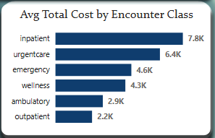
Approach
- I created a measure Avg Cost per Encounter from the Total Cost column in encounters table
DAX Formula: Avg Cost per Encounter = AVERAGE('Encounters'[TOTAL_COST])
- Then visualized using a line chart
X-axis = Avg Cost per Encounter
Y-axis = ENCOUNTER CLASS

Findings
- The data shows that the Inpatient($7.8k), urgent care($6.4k), emergency class($4.6k),turned out to be top 3 encounter class avg cost
- Ambulatory($2.9k) and Outpatient($2.2k) Class had the lowest costs
Insights
The classes that drive the highest costs, is likely due to the intensive treatment, longer duration of care, and higher resource use required for these cases.
Drill-Through
- Which encounter class has most unpaid costs from insurers?
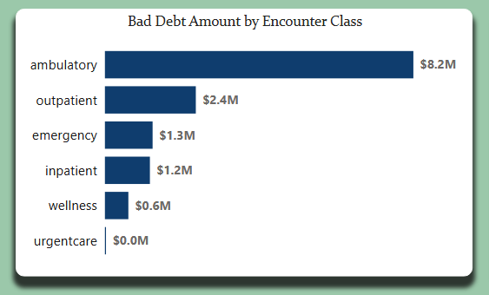
Approach
- I visualized using a bar chart
X-axis = BadDebtAmount
Y-axis = ENCOUNTER CLASS
2. Coverage distribution (insured vs uninsured)
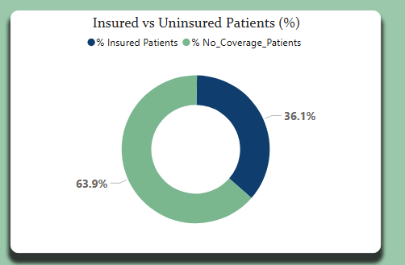
Approach
- I created 2 measures % No_Coverage_Patients & % Insured Patients
DAX Formula: % No_Coverage_Patients = VAR Num = CALCULATE(
DISTINCTCOUNT('Encounters'[Patient]),
FILTER(
ALLSELECTED('Encounters'),
ISBLANK('Encounters'[Payer_Coverage]) || 'Encounters'[Payer_Coverage] = 0
)
)
VAR Den =
CALCULATE(
DISTINCTCOUNT('Encounters'[Patient]),
ALLSELECTED('Encounters') )
RETURN
DIVIDE( Num, Den, 0 )
DAX Formula: % Insured Patients = 1 - [% No_Coverage_Patients]

- Then visualized using a Donut chart
Values = %Insured Patients, %No_Coverage_Patients
3. Which encounter class generates the most revenue(proxy)?
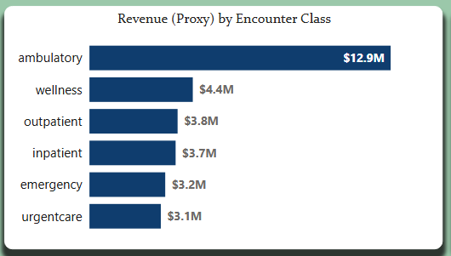
Approach
- I visualized using a bar chart
X-axis = Revenue (Proxy) (Aggregated with Sum)
Y-axis = ENCOUNTER CLASS
4. What are the most common procedures, and how do their costs compare?
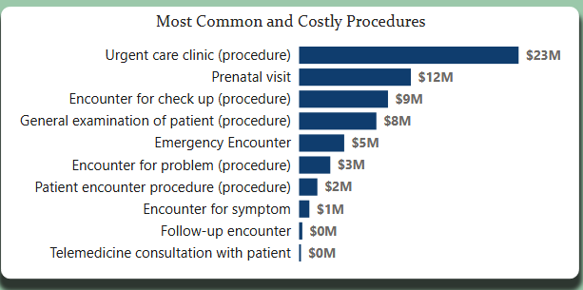
Approach
- I visualized using a bar chart
X-axis = TOTAL_COST (Sum)
Y-axis = DESCRIPTION
Tooltip
1a. Which encounter classes drive the highest total costs?
Approach
- I visualized using a bar chart
X-axis = Total Cost(Sum)
Y-axis = ENCOUNTER CLASS
1b. Encounter classes with highest base cost
Approach
- I visualized using a bar chart
X-axis = Base_Encounter_Cost(Sum)
Y-axis = ENCOUNTER CLASS

2. Insurance coverage counts by race
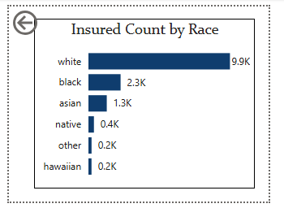
Approach
- I created a measure Insured Count
- DAX Formula: Insured Count = COUNTROWS( FILTER( 'Encounters',
NOT ISBLANK('Encounters'[Payer_Coverage]) && 'Encounters'[Payer_Coverage] > 0 ) )
Then visualized using a bar chart
X-axis = Insured Count
Y-axis = Race

SUMMARY OF ANALYSIS/RESULTS
Healthcare Quality Issues: High readmission and mortality rates in ambulatory and inpatient classes, with many deaths linked to unclear or misclassified encounter reasons.
Operational efficiency risks: Inpatient, ambulatory, and outpatient classes show prolonged stays, indicating inefficiencies in patient turnover and case management.
Cost management issues: Inpatient, urgent care, and emergency classes drive the highest treatment costs, while urgent care and emergency generate low or negative profit margins.
Coverage Gap & Access Inequities: Insurance coverage is concentrated in lower-risk classes, while high-risk groups and races like Natives, Blacks, and Hawaiians face higher out-of-pocket expenses.
RECOMMENDATIONS
- Investigate deaths, long stays, and 3 a.m. encounter spikes in ambulatory care. Improve triage systems and strengthen follow-up care.
- Focus on inpatient, urgent, and emergency encounters. Expand preventive care and better coordinate patient management to cut costs.
- With only 36% insured, launch stronger enrollment drives, offer financial counseling, and renegotiate payer terms to close the gap.
- Certain demographic groups face higher out-of-pocket (OOP) costs. Review billing and coverage structures to ensure fairness and affordability across all populations. Prioritize income- or needs-based relief programs.
5. Wellness and inpatient care have better coverage than emergency or urgent care. Advocate with payers for fair coverage across all classes.
6. Use the Affordable Care Act (ACA) and the Mental Health Parity and Addiction Equity Act (MHPAEA) to challenge under-coverage, especially for substance use disorder (SUD) and mental health (MH) services.
CONCLUSION
Healthcare utilization and access will only improve when quality care delivery, efficient resource management, and fair insurance structures work in balance — supported by government policies that hold payers accountable for covering necessary costs as required by law.

